Deaf or Hard of Hearing

Deafness is complete hearing loss in both ears. Hard of Hearing is mild or moderate hearing loss in one or both ears.

What is Deaf Culture? Source: https://www.deafhear.ie/DeafHear/whatIsDeafCulture.html

Deaf Culture and the Deaf Community are associated with people who are born Deaf, and generally use sign language to communicate.
Cultural Patterns

It often comes as a surprise to hearing people that many Deaf people refer to themselves as being members of the Deaf Community. The Deaf Community is a unique linguistic minority that uses sign language as its primary mode of communication. Within the Community, Deaf Culture naturally evolves and has its own unique values and ways of interacting. Examples include:
- Collectivism
- Social Customs

Collectivism

Deaf people consider themselves members of a group that includes all Deaf people. Deaf communities are close-knit and interconnected.

Deaf people greatly enjoy being in the company of other Deaf people and will actively seek ways to do this, for example, 21st birthday parties; people will travel from Roscommon, Donegal etc. to attend a party in Cork. When Deaf people first meet, the initial goal is usually to find out where the person is from and to identify the Deaf friends they have in common.

Social Customs

The behaviours associated with cultural values are deeply rooted. We do not consciously think about the rules involved when making introductions or how to say goodbye when we leave. As children, we saw these behaviours repeated often and have long since fully incorporated them into our cultural repertoire.

It is only when we are placed in a culture that uses different rules that we realise there is another possible way to accomplish the same task. For example, when a Deaf person leaves a gathering of other Deaf people, the process is quite lengthy. In Deaf Culture, one approaches each group to say goodbye, which often results in further conversation. The entire process can take more time to accomplish than just saying goodbye. This behaviour may seem unusual; however, if we remember that Deaf Culture highly values being interconnected with all of its members, the behaviour makes a great deal of sense.

Deaf Culture Facts:
Source: http://www.secondcityspeech.com/the-speech-path/2014/8/18/10-facts-you-probably-didnt-know-about-sign-language

1. ASL is not just a signed form of English.

ASL is a completely separate language with its own vocabulary, word order, and style. It's actually based off of French Sign Language and the homespun sign languages used in Martha's Vineyard in the 19th century. In fact, many English words that don't exist in ASL are often spelled out using fingerspelling.

2. Not all people who are deaf want to correct their hearing.

Some deaf and hard-of-hearing people identify with the Deaf (spelled with a big D) culture, which embraces using American Sign Language and emphasizes hearing loss as a difference rather than a disability. The Deaf community is made up not only of people with hearing loss, but their children, family, and friends who identify with these shared beliefs. Some members of the Deaf community feel like using hearing aids or cochlear implants are a sign of being ashamed of their hearing loss, and instead choose to embrace living independently without correcting their hearing.

The film Sound and Fury follows a Deaf family's difficult decision of whether to give their daughter a cochlear implant, a device that simulates hearing. You can watch the full film on YouTube or Netflix. Video borrowed from YouTube and pbs.org.

3. ASL uses facial expressions for certain words and meanings.
Here the signer asks, "You?" by raising his eyebrows. Image borrowed from lifeprint.com.
Here the signer asks, "You?" by raising his eyebrows. Image borrowed from lifeprint.com.

ASL can use facial expressions to change the meaning of signs without changing the signs themselves. For example, raising your eyebrows indicates a yes/no question. You can sign "eat" and mean, "You eat" or, "Do you want to eat?" just by changing your facial expression.

4. There are many different sign languages around the world.

In North and South America alone, there are over 35 different sign languages including American Sign Language, Peruvian Sign Language, and Greenlandic Sign Language. In addition to true signed languages, there are also signed representations of oral languages such as Signed Exact English (SEE) and mixes such as Pidgin Signed English (PSE).

5. Deaf babies babble in sign language just like hearing babies babble in speech.

During the development of hearing babies, we see them explore the sounds they can make through babbling. This is the first stage of learning how to talk and usually starts with simple sounds like "ba ba ba". Babies who are deaf don't get the same benefit of hearing themselves babble, so they may not babble using speech as much if at all. Instead, deaf babies explore the hand shapes and movements that make up signs by babbling with their hands. In fact, even hearing babies with deaf parents will also start manually babbling in addition to vocal babbling. Research has shown that the language development of hearing and deaf babies is the same as long as they are provided good language input. Deaf babies who are born to hearing parents who do not learn sign, however, are put at risk for delayed language development because they cannot hear the language models all around them.

6. Even trained lipreaders can only understand about 30% of speech.

Many sounds use nearly identical mouth movements, and thus are very difficult to tell apart without sound. For example, the sounds /b/ and /p/ are made in the same place of the mouth (the lips) and in the same way (a short burst of air, called a stop). What differs between these sounds is voicing, or whether we use our vocal folds when we speak. You can feel the difference if you hold your hand to your throat to say "bat" and "pat". You should feel a vibration in your throat at the start of "bat", but not at the start of "pat". These voicing distinctions are nearly imperceptible with just vision alone, though.

It's also difficult to see sounds that are made further back in the mouth, like /k/. Combine these lacking visual cues with how fast we move our mouths in actual conversation, and you can see why relying on vision alone would be difficult. Try this out yourself by watching actors speak on television with the sound turned off, and see how much of the conversation you miss. This is what many deaf people trained in oral-only programs experience every day. Of course, learning these visual cues can help support any remaining hearing, but even the most well trained lip readers get only about 30% of the conversation through lipreading alone.

7. Deaf children have created their own sign languages.

In the 1970s and 1980s, many deaf children in Nicaragua were placed in schools for the deaf for the first time. No schools for the deaf existed in the country prior to this, so these children had grown up using homemade sign languages and gestures known only to their friends and family. The school's teachers used mostly Spanish and lipreading with the students, which proved unsuccessful. Left to their own devices, the students in the school quickly began combining their home signs with new ones, creating an entirely new sign language that they used to communicate with each other. Researchers noticed that as more generations of students passed through the school, this primitive language began to evolve and grow, becoming a truly new language born out of necessity. This is the only instance of a new language being created from scratch that scientists have been able to document.

8. The sign for "I love you" combines the signs for the letters I, L, and Y.
The sign for "I love you" in American Sign Language. "I+L+K=ILKsign" by 金肅 - Own work. Licensed under Creative Commons Attribution-Share Alike 3.0 via Wikimedia Commons.
The sign for "I love you" in American Sign Language. "I+L+K=ILKsign" by 金肅 - Own work. Licensed under Creative Commons Attribution-Share Alike 3.0 via Wikimedia Commons.

The sign for "I love you", as pictured above, is actually a combination of the three letters "I", "L", and "Y". There is some debate on when the sign was created, with theories ranging from 1905 to the 1970s. It gained popularity in mainstream culture after Richard Dawkins of Family Feud fame and President Jimmy Carter began using the sign. Be careful, though! This sign is different from the "horns out" hand gesture used at rock concerts where the thumb is tucked in.

9. Gallaudet University in Washington, D.C. teaches most of its courses in American Sign Language.

Pronounced "Gal-uh-det", Gallaudet University was founded in 1864 and serves as one of the two major universities for deaf and hard-of-hearing students in America. Most courses taught at the university are offered in ASL, although they also offer an English learning program and ASL classes for those learning it as a second language. Gallaudet has played a prominent role in Deaf culture.

10. Children of deaf adults learn to speak just like children with hearing parents.

Hearing children of deaf adults (also called CODAs) will follow the same developmental path as their peers who have hearing parents. In fact, many of these children will grow up bilingual and bi-cultural, with their first language as ASL and their second language as English. These children pick up speech through friends, hearing family, and peers at school, and grow up to live normal, productive lives. Many of these children train to become interpreters or serve as "go-betweens" for the Deaf and hearing communities by teaching ASL.

Myths
Source:
https://ifmyhandscouldspeak.wordpress.com/common-myths-about-deaf-people-and-the-truth/

“All Deaf people can read lips, and as long as I speak distinctly and look at them, they will always understand every word I have to say”. Actually, lip reading is an amazingly ineffective way of communicating. It’s estimated that lipreaders can understand only 30% of the conversation taking place. That’s like missing two of every three words being spoken! In situations where the Deaf person is familiar with the speaker or the conversation is easily predictable (such as at a check out stand) comprehension goes up to 60%, but that’s still almost every other word missing from the exchange. Pretty terrible, really.

“All Deaf people were taught to speak in school using an easy process where each letter has a mouth shape they learn, and then they’re good to go.” Though some Deaf people were taught to speak in Oral schools using a tedious process requiring years and years of one-on-one study, many Deaf people do not speak. That’s OK, they are really adept at communicating with Hearing people in other ways. You should be flexible and let them get their point across with pen and paper, or anything else that works for them.

“Deafness is genetic. All people who are Deaf will pass Deafness onto their children.” There is a type of Deafness that is genetic, and some Deaf people do have Deaf children, however 90% of all Deaf people were born to Hearing parents and will also have Hearing children. There has been no proven scientific basis for the policies of Eugenics that have plagued Deaf adults since this country was founded.

“Sign Language is bad for Deaf people because they will rely on it too much and it will make them unable to communicate with Hearing people.” Study after study has shown that keeping Sign Language away from Deaf people does nothing except keep all language away from Deaf people, and it can have numerous negative effects on their ability to learn. Even Deaf adults who have never learned to speak still live in a world that is mostly Hearing, and have developed incredible skills for making themselves understood. On another note, Doctors are continually saying how good Sign Language is for Hearing babies, why would this not be true for Deaf babies as well?

“Sign Language is universal. People from over seas and people from America get together and can instantly understand each other.” Actually, there are at least 70 signed languages existing in the world at this time, that we know of, and all of them are incredibly distinct. American Sign Language is used in the United States, parts of Canada, and some South American countries, and has loose relations to French Sign Language (much like French and Italian are related). British Sign Language is completely different and BSL signers and ASL signers are as incomprehensible to one another as German speakers and Italian speakers.

“But when I see Deaf people from different countries get together, they seem to communicate just fine…” Deaf people have a lot of experience communicating with Hearing people who don’t understand them, no matter what country they are from. When Deaf people get together with other Deafs who don’t speak their language, they already have a ton of practice making themselves understood and are able to draw on this experience to communicate with each other more easily than Hearing people in the same situation.

“Deaf people don’t want to be deaf, they are hoping for some miracle cure that will make them hear.” – Deaf people actually like being deaf. They consider it more peaceful than being able to hear everything all the time. Most Deaf people I’ve talked to also feel like the majority of hearing people are insensitive and oblivious. They don’t want to belong to a community like that.

“Deaf people can’t drive a car.” – Deaf people drive cars all the time. In fact, some studies have shown that Deaf people are actually better drivers than Hearing people due to the fact that Deaf people have enhanced peripheral vision. If you think about it, nothing about driving really requires you to be able to hear. After all, there’s a reason emergency vehicles have both sirens and lights.

“Deaf people read Braille.” – Braille is a writing system where each letter is represented by a series of raised dots. This makes it so that Blind people can read, even if they can’t see. There’s some scientific evidence that Deaf people see better than hearing people. They’re just fine reading the regular way.

Deaf Access in the workplace
Source:http://www.signlanguagenyc.com/creating-deaf-accessibility-in-the-workplace/

Most hearing people rarely think about deaf accommodations. When it comes to hiring deaf employees, they are concerned that it will be a costly or inconvenient process. Potential employers might worry that communication will be challenging, and the deaf employee will have trouble integrating with the team. These fears are unfounded, and they usually stem from inadequate corporate cultural sensitivity education. The bottom line is that hearing employers simply don’t understand what it means to be deaf, and so it seems easier to just hire a hearing person… even if they are less qualified for the job. This is discrimination, and it’s sadly commonplace.

The first step to hiring a deaf employee is opening a comfortable line of communication. Not sure how? Just ask! Deaf people spend their whole lives learning to interact with mainstream culture, and each person does it a little differently. Some deaf people prefer written communication, others are ok with reading lips, and still others prefer an ASL interpreter– there is no one-size-fits-all solution. Trust me, you will not offend your deaf interviewee by asking him or her what type of communication they like to use!

Deaf Access in the workplace NYCWhen you decide to hire a deaf candidate, some workplace adjustments will need to be made. Your training videos should already be captioned; if they are not, you can have them captioned for a very reasonable fee. According to the ADA, it is the deaf individual’s responsibility to inform an employer where accommodations are needed. Employers are obligated by law to make any “reasonable accommodations” which enable their employee to work effectively. Most of these adjustments will depend on the person’s individual preferences. Not sure? Just ask!

Deaf access in the workplace NYCBusinesses must provide deaf employees with the auxiliary devices they need to communicate equally. With unlimited access to email, text, and chats, it is easier than ever to make your workflow deaf-friendly. Generally, the most important device will be a video phone. Businesses can obtain video phones and Video Relay Services for free, VRS providers are reimbursed by the Interstate Telecommunications Relay Service Fund. Using the VRS, your deaf employee is connected with a communications assistant through video chat. The video interpreter will engage with the deaf person using their preferred modality, and vocally interpret for the hearing parties. This means that when a hearing client, manager, or coworker needs to discuss something with a deaf employee, they can just use the VRS to quickly and conveniently do so; whether they are across the country or just across the hall.

Deaf access in workplace NYCFor meetings, you will need to enlist a deaf service provider– either a captionist or interpreter. Meetings can be very involved and fast-paced. Even the most expert lip readers have difficulty keeping up when there are 20 people in the room discussing things out of turn. You want everyone in your organization to feel like their participation is valued, so be sure you ask your deaf employee how you can better facilitate this. When hiring an interpreter or service provider , be sure to submit your request as far in advance as you are able.

As far as cost concerns, there are specific Federal tax credits and tax deductions available to employers, and you will find there are also other public and private sources of funding available for ADA required accommodations. This means service providers and equipment charges can often be reimbursed at little cost to your business.

Deaf Access NYC - Claudia GordonEquality starts from the top down. Diverse leadership promotes social tolerance, and we are finally beginning to see deaf officials in major institutions such the White House and the FCC. When business owners, executives, and managers become educated about multicultural issues, the entire organization benefits. When your staff understands how to integrate a deaf individual onto the team, you are helping bridge the cultural divide and create true equality.

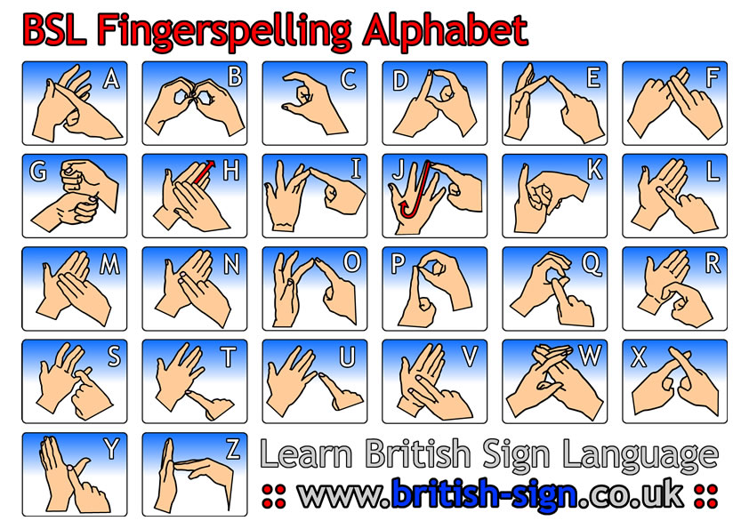

British or Irish Sign Language
Source: https://www.deafhear.ie/DeafHear/irishSignLanguage.html

Another important aspect of Deaf Culture for Deaf people is their language - ISL.
Most Deaf people spend the majority of their lives with people who do not know ISL.

It is only when Deaf people are in the presence of other Deaf people that all communication barriers are removed.

It is obvious to most people that ISL is a visual language. What is not so obvious is how the visual nature of the language impacts on the rules for communication. In spoken languages there is no requirement for eye contact between the speaker and listener. In fact, we spend very little time looking at each other. We are not used to maintaining eye contact for long periods of time. Also, we often allow environmental noises to take our attention and we divert our eyes. In a signed conversation the ’listener’ must always look at the ’speaker.’ From a Deaf perspective, broken eye contact or the lack of eye contact shows indifference.

Most hearing people do not freely and effectively use their face and body to communicate so Deaf people see their communication as lifeless and lacking emotion. Facial expression and body language are integral parts of ISL. Deaf people have an exceptional ability to use and read non-verbal communication. They pick up on very subtle facial and body movements. An important aspect of body language is the use of touch. Touching another person is used in Deaf Culture to greet, say goodbye, get attention and express emotion.

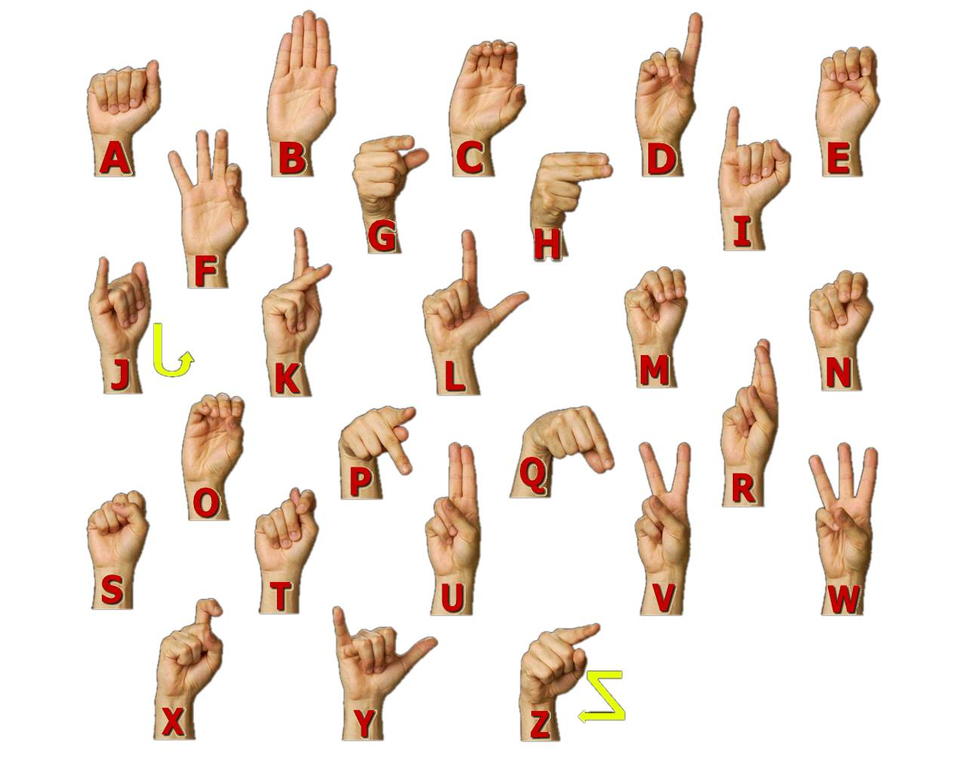
Image: https://www.google.com/?client=safari#q=ASL&tbm=isch&imgrc=4AL4VxD6yajABM%3A

American Sign Language
Source: http://www.nidcd.nih.gov/health/hearing/pages/asl.aspx

American Sign Language (ASL) is a complete, complex language that employs signs made by moving the hands combined with facial expressions and postures of the body. It is the primary language of many North Americans who are deaf and is one of several communication options used by people who are deaf or hard-of-hearing.

